Project Development Phase Sprint - II

|  |  |
| --- | --- |
| **Date** | **12 November 2022** |
| **Team ID** | **PNT2022TMID46219** |
| **Project Name** | **Natural Disasters Intensity Analysis And Classification Using Artificial Intelligence** |
| **Maximum Marks** | **4 Marks** |

Building the CNN Model for Natural Disaster Classification, Training and Validating it, and Testing results

1. **Indexing Disaster Classes**
2. 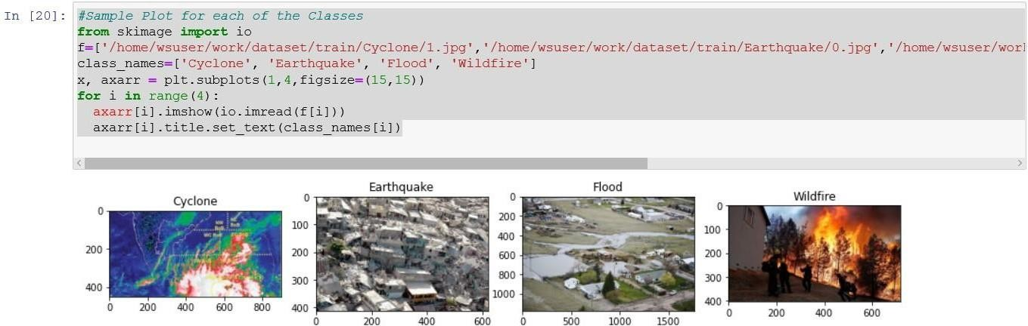**Sample Plot for each of the Classes**
3. **CNN Model Architecture**

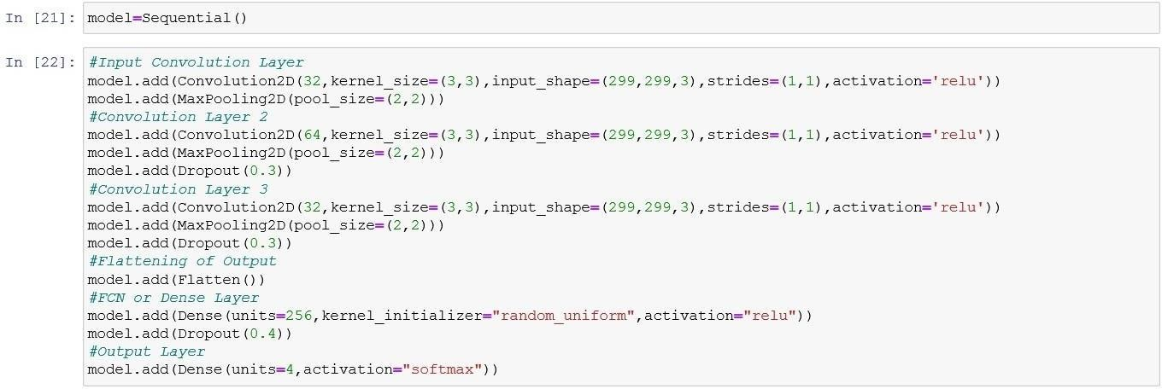

1. 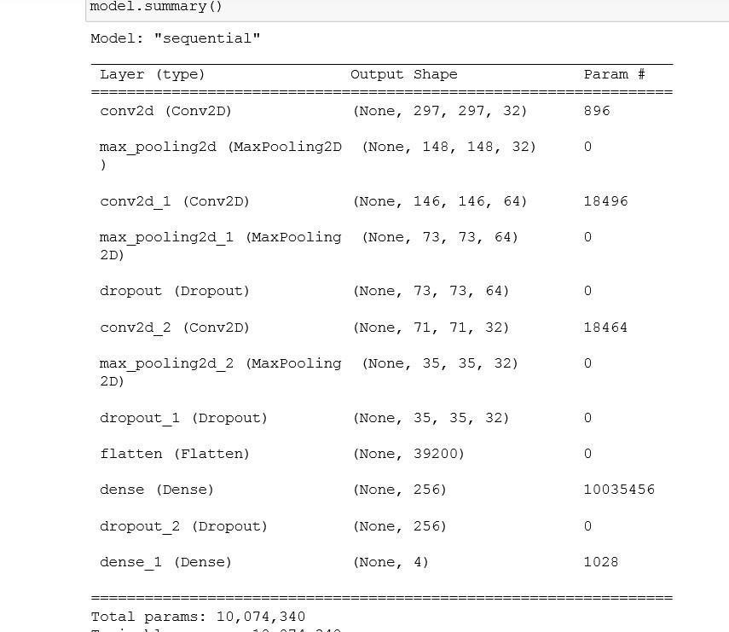**Summary of the Model**
2. **Compiling the Model**



1. 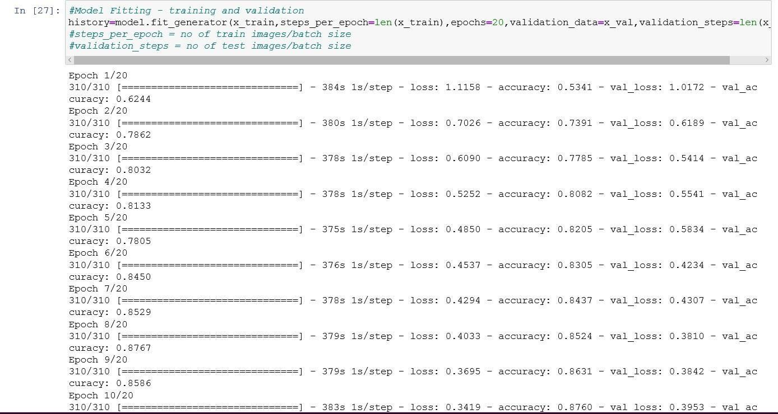**Training and Validating the Model**

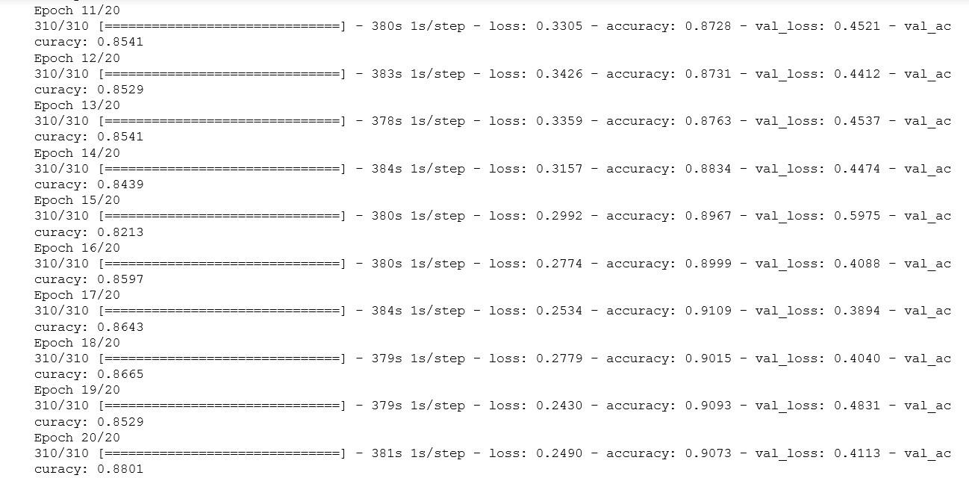

1. 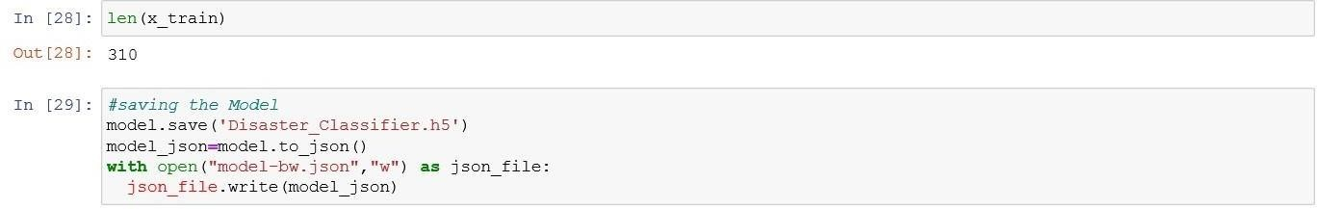**Saving the Model as .h5 file and json file**
2. **Plots for training vs validation accuracies and losses**

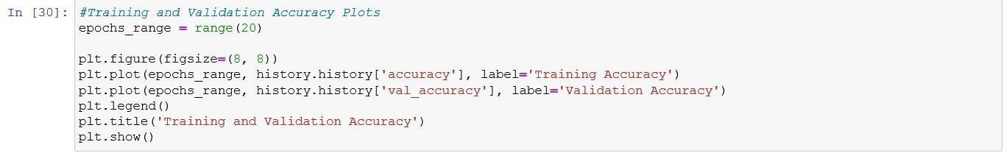

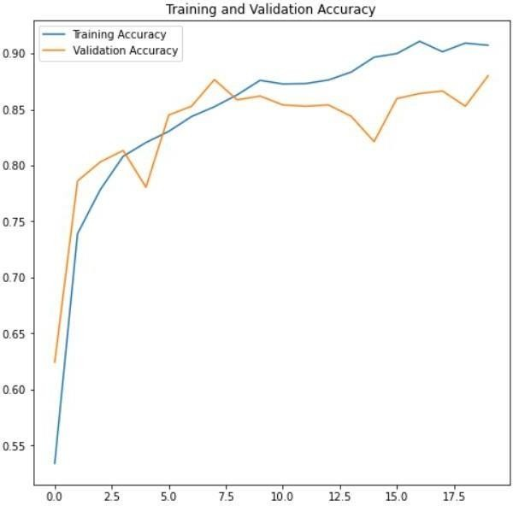

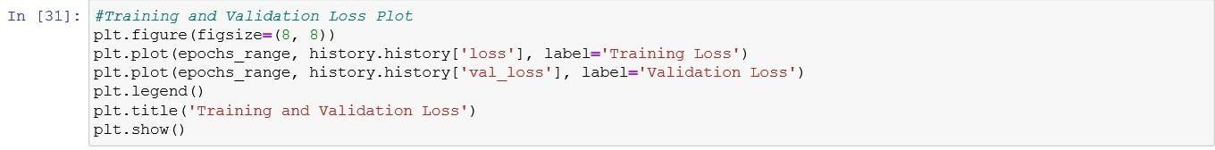

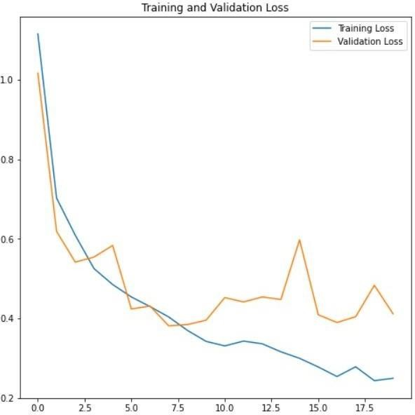

1. **Testing the CNN Model with test d**

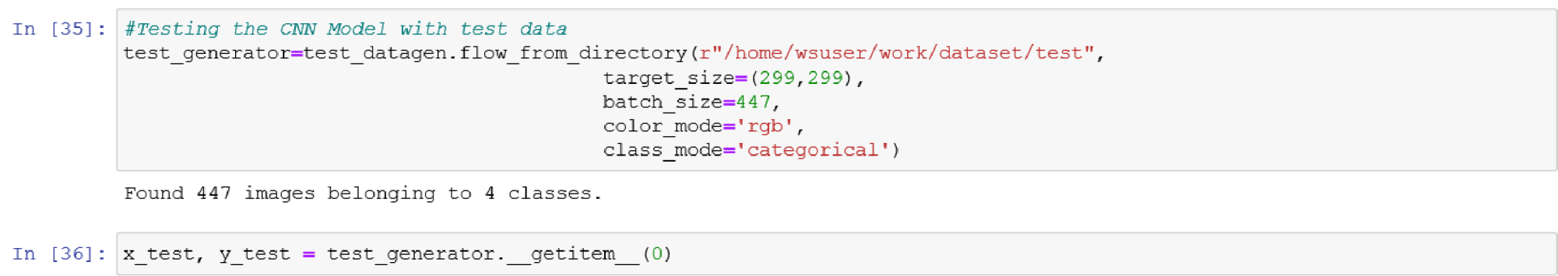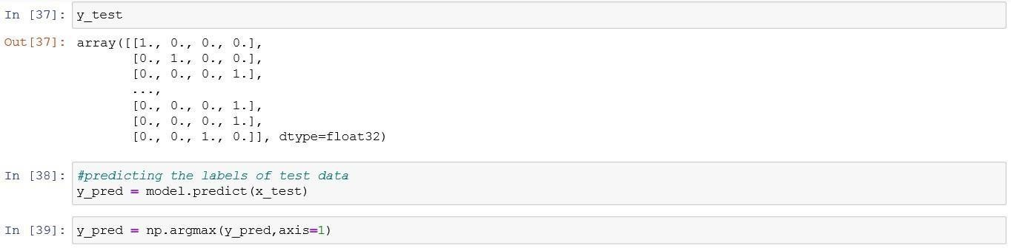

ata

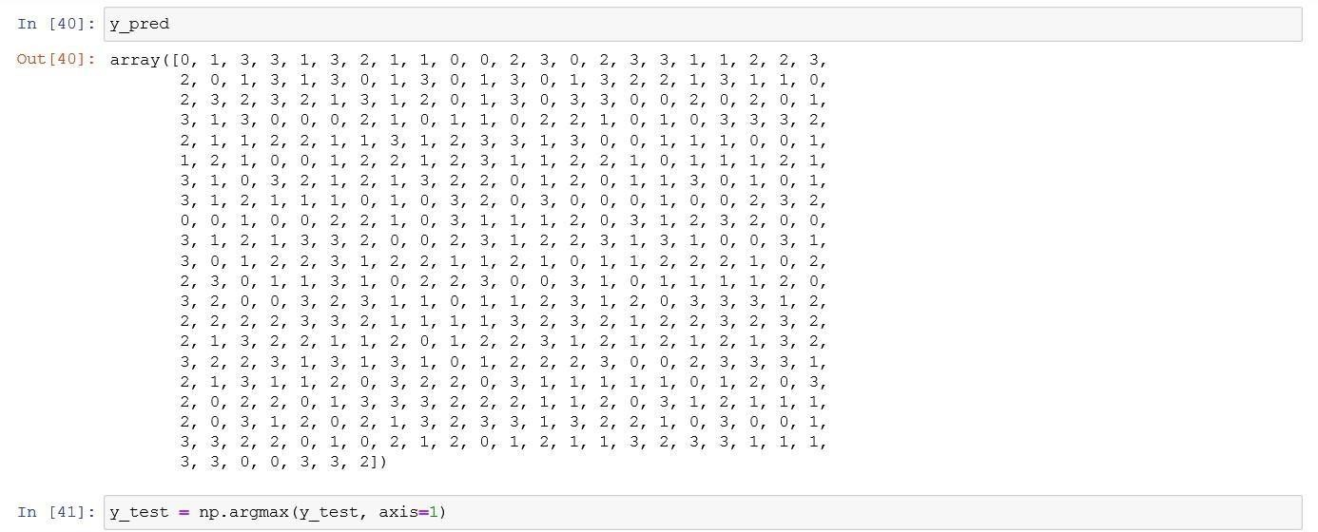

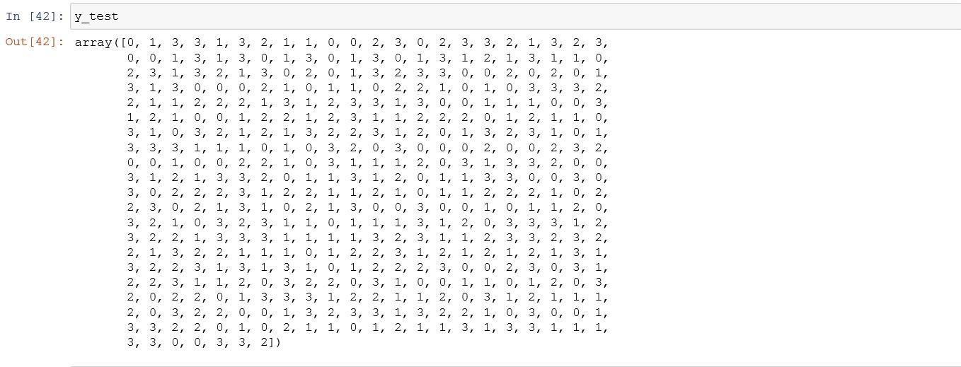

1. **Generating Classification Report with F1 Score**

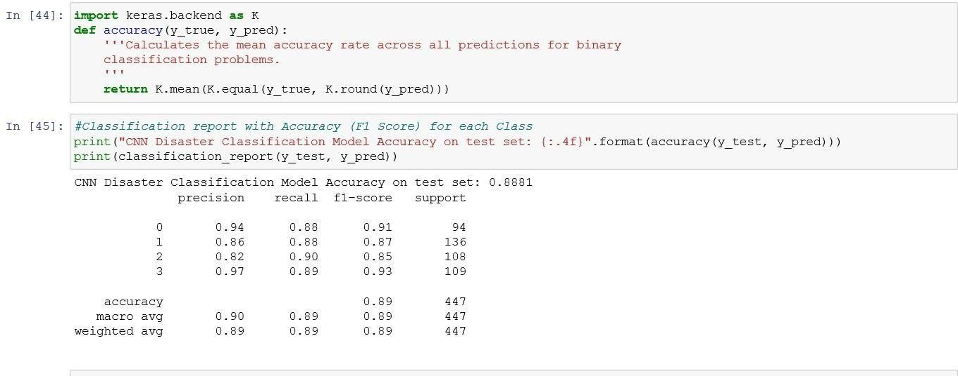

1. **Weighted Accuracy of the model**



1. **Confusion Matrix for test data**

